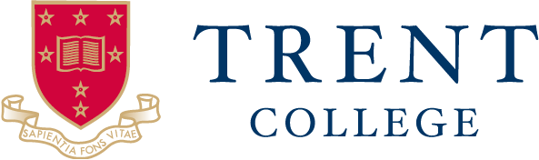
JOB DESCRIPTION
Position Title: Domestic Assistant
Overall Scope of the Post:
Situated on the border of Nottingham and Derbyshire in Long Eaton, Trent College and its Junior School and Nursery, The Elms, are co-educational independent schools, educating pupils from 6 weeks to 18 years old. Founded in 1868, the school combines the traditional with the modern, with the main building sitting at the heart of a striking 45-acre campus, complemented by modern facilities and creative spaces.
Core Objectives for the Role:
- To support the department’s management team in ensuring the facilities at Trent are kept to the best standard.
- To carry out cleaning tasks as directed and in support of other team members’ activities in delivery of services to the required standard.
Key Responsibilities:
- To follow the instructions and advice of the management team in delivery of the services.
- To provide efficient and effective cleaning support, ensuring that the security and general appearance of the buildings and surrounding areas are maintained in accordance with the required standards, in a timely fashion, by using the correct methods.
- The post holder will be expected to observe safe working practices in carrying out the required duties and ensure that instructions specified are adhered to.
- To carry out ad hoc cleaning duties as necessary or as requested by your line manager. Daily cleans of the buildings including, but not limited to:
- Emptying waste bins or similar receptacles, transporting waste material to designated collection points
- Sweep /Damp mop resilient floor surfaces
- Vacuuming of carpeted areas· Daily ‘Spot’ clean carpeted floor areas to remove spillages and bonnet buff carpets as required
- Spray burnishes resilient floor surfaces· Dust, damp wipe, wash furniture, ledges, window sills, external surfaces of cupboards, radiators, shelves and fitments
- Clean toilets, urinals, hand basins, kitchen sinks and drinking fountains· Undertake wall washing and cleaning of window blinds, and inside window pane cleaning.
- Carry out any other reasonable function to the job
Staff
- To support all team members in carrying out daily tasks.
- To work at all times with consideration for the safety and wellbeing of colleagues.
- Attend and practice all training provided.
- To report any breaches of expected staff conduct to the Director of Operations or Services Manager.
General
- To communicate effectively with both students, visitors and colleagues at all levels of seniority and to liaise as required with other internal departments.
- To show good interpersonal and customer facing skills, be able to empathise, maintain professionalism, display patience and politeness within a sometimes pressurised environment.
- To show a conscientious, flexible, ‘can-do’ working style.
- Be confident to deal with difficult situations and know when it is appropriate to seek guidance from line managers.
- To show good team working skills and to have the ability to work under minimal supervision.
- To have a good level of physical fitness and the ability to undertake manual work.
- To practice confidentiality and discretion and to have an awareness of the Date Protection Act.
Line Management
- The Domestic Assistant reports directly to the Services Manager. The Services Manager will allocate their duties and be responsible for their supervision, quality of work, safety, motivation, discipline and training.
Working Hours/Shift Pattern
- The post holder works: 0600 to 0900 Monday to Friday term time only
- Saturdays on a 1 in 4 rolling rota 0700 – 1000
- (paid meal breaks depended on hours worked)
Holiday Entitlement
4 weeks to be taken during School holidays.
Uniforms
Uniforms will be provided.

